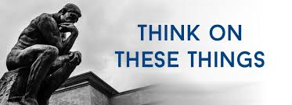

**ELECTION**

We have just gone through a very important election. The results of this election will determine who holds the power both in the Senate and Congress of the United States. We, the people, were the ones who selected certain individuals by casting a vote in favor of the candidate of our choice.

While political elections are important, there is another election that far succeeds these elections in importance. Peter wrote: *Therefore, my brothers, be all the more eager to make your calling and election sure. For if you do these things, you will never fall, 11 and you will receive a rich welcome into the eternal kingdom of our Lord and Savior Jesus Christ* ( 2 Peter 1:10-11). Notice we are told to make our election sure. Modern day politicians spend millions of dollars in an attempt to win an election. But notice the words “make your election sure.” We need to understand who the “elect” are. Those who obey the Gospel of Jesus Christ are God’s “elect.” Notice Paul’s words: *Paul, a servant of God and an apostle of Jesus Christ for the faith of God's elect and the knowledge of the truth that leads to godliness—* (Titus 1:1-2).

As Christians, we have been elected by God to be His children. The Bible does not teach predestination, but it does assure us that God chooses those who obey His Gospel. The admonition to make our election sure is evidence that there is something we have to do. We have to obey the Gospel and then live as we are directed in God’s Word. A very simple way to understand God’s election is to realize God predestined the PLAN, not the MAN.

Let’s be “eager” to make our calling and election sure. If we do these things we will never fall and will receive a rich welcome into the Kingdom.

A

**VOLUME 25 Nov 13, 2022 Number 45 3893333343431**

***Welcome to our services*  SUNDAY Worship…………………………………9:30 AM Bible Class……………………………10:45 AM MONDAY Bible Study……………………………6:30PM WEDNESDAY Bible Study……………………..…..7:00 PM THURSDAY W.I.N.G.S. (Women In God’s Service) Ladies’ Bible Class…………….10:00 AM**

**Monday PM, Wednesday PM and Thursday AM classes will all meet in the West Annex for the present time**

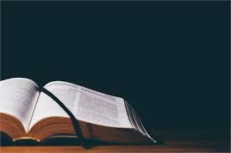

**Sermon:**

**The Greatness Of God**

Friday Christians



**SKYVIEW CHURCH OF CHRIST 5972 62ND Avenue N. Pinellas Park, Fl –33782**

