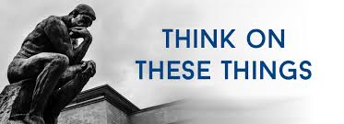

**BIBLE VERSES FOR THE NEW YEAR**

The Bible can be a great source of guidance and encouragement during the holiday season or any new beginning. Here are some scriptures about hope that may touch your heart.

* Praise be to the God and Father of our Lord Jesus Christ! In his great mercy He has given us new birth into a living hope through the resurrection of Jesus Christ from the dead. 1 Peter 1:3.
* For I know the plans I have for you, says the Lord. They are plans for good and not for disaster, to give you a future and a hope. Jeremiah 29:11
* In his heart a man plans his course, but the Lord determines his steps. Proverbs 16:9.
* Look to the Lord and His strength; seek His face always. Remember the wonders He has done, His miracles, and the judgments He pronounced. 1 Chronicles 16:11-12.
* Therefore if anyone is in Christ, he is a new creation; old things have passed away; behold, all things have become new. 2 Corinthians 5:17.
* So we say with confidence, “the Lord is my helper; I will not be afraid. What can mortals do to me”” Hebrews 13:6.
* Remember not the former things, nor consider the things of old. Behold I am doing a new thing… Lam. 3:22-24
* He has made everything beautiful in its time. He has set eternity in the hearts of men; yet they cannot fathom what God has done from beginning to end. Ecc. 3:11.
* “……those who wait for the Lord will gain new strength; they will mount up with wings like eagles, they will run and not get tired, they will walk and not become weary. Is, 40:31.

**MAY GOD’S RICHEST BLESSINGS BE YOURS IN 2023**

A

**VOLUME 25 Jan 1, 2023 Number 1 3893333343431**

***Welcome to our services*  SUNDAY Worship…………………………………9:30 AM Bible Class……………………………10:45 AM MONDAY Bible Study……………………………6:30PM WEDNESDAY Bible Study……………………..…..7:00 PM THURSDAY W.I.N.G.S. (Women In God’s Service) Ladies’ Bible Class…………….10:00 AM**

**Monday PM, Wednesday PM and Thursday AM classes will all meet in the West Annex for the present time**

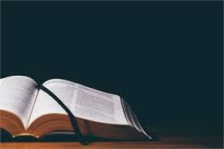

**Sermon: Calvin McCoy**

Friday Christians



**SKYVIEW CHURCH OF CHRIST 5972 62ND Avenue N. Pinellas Park, Fl –33782**

