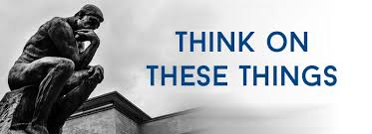

**AI**

We hear a lot about “AI” today. I did not fully understand what it meant, so I looked it up. Here is a *very brief definition: “Artificial intelligence leverages computers and machines to mimic the problem-solving and decision-making capabilities of the human mind.”* AI stands for artificial intelligence which is a way of saying that computers are now being programmed to think and act like humans.

We now have cars that can drive themselves. I have a car that is able to stop itself when an accident is about to occur. We have lights and objects in our home that are voice controlled. They are programmed to recognize our specific voice. When I had my last hip replacement surgery a robot actually performed the operation. From what I can learn, AI will one day replace our thinking process. We don’t have to think for our self, a computer will do it for us.

While all of this may sound good (or bad) it is an attempt to improve on God’s creation. We were created with a soul (heart) which is the seat of man. It is with our soul (heart) that we think, reason, learn, and have emotions and make decisions. Love is one of the emotions that stem from the heart of man. A machine cannot love. A machine can not feel any emotion. We may be able to train a machine to operate by voice command, but that machine has no volition or emotion. As humans we have control over our thoughts and actions and we will be judged by God as to how we use them. The wise man of the Old Testament expressed it like this: Eccl 12:13 *Now all has been heard; here is the conclusion of the matter: Fear God and keep his commandments, for this is the whole [duty] of man.* As humans the whole of man is to fear God and keep His commandments.

A

.

**VOLUME 25 July 23, 2023 NUMBER 31**

***Welcome to our services*  SUNDAY Worship…………………………………9:30 AM Bible Class……………………………10:45 AM MONDAY Bible Study……………………………6:30PM WEDNESDAY Bible Study……………………..…..7:00 PM THURSDAY W.I.N.G.S. (Women In God’s Service) Ladies’ Bible Class…………….10:00 AM**

**Monday PM, Wednesday PM and Thursday AM classes will all meet in the West Annex for the present time**

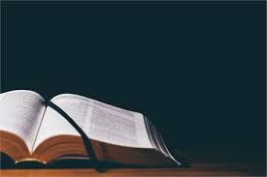

**Sermon: GETTING USED TO THE SMELL Charles Murray**



**SKYVIEW CHURCH OF CHRIST 5972 62ND Avenue N. Pinellas Park, Fl –33782**

