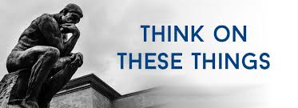

Every year my wife buys the latest **OLD FARMER’S ALMANAC**. She is not a farmer, but this little book has all kinds of useful information. It tells the best time to plant, gives information about the predicted weather, shows the different time zones across the US. It tells about the sun, moon, stars and planets. It also has a section on nature and even tells the best fishing days and times. This is all useful information.

The Christian also has an almanac. This book has all kinds of important information. It tells about the origin of the sun, moon, stars and planets. It reveals the beginning of time and the origin of all living things. But more importantly, it tells us how to live to be pleasing to God our Creator. While the almanac contains ads offering products that can help us with our physical health, God’s almanac offers free information about how we can not only achieve a healthy, balanced physical life, it reveals how we can be well spiritually. The Bible (God’s Almanac) tells us that our bodies are the temple of God. It reveals that God lives in us and how we can maintain the physical body to enjoy life here and hereafter. It gives us the formula for a spiritual existence that not only pleases God, but results in a healthy, strong existence.

While the Farmer’s Almanac is invaluable to the farmer, God’s Almanac, the Bible, is invaluable to the Christian. We cannot succeed without it. Why not give it a try? Why not read it and apply its teachings to your life? On the opening page of the almanac is the following:

***The moments fly ---a minute’s gone; The minutes fly---an hour is run; The day is fled----the night is here; Thus flies a week, a month, a year!***

A

.

**VOLUME 25 August 6, 2023 NUMBER 33**

***Welcome to our services*  SUNDAY Worship…………………………………9:30 AM Bible Class……………………………10:45 AM MONDAY Bible Study……………………………6:30PM WEDNESDAY Bible Study……………………..…..7:00 PM THURSDAY W.I.N.G.S. (Women In God’s Service) Ladies’ Bible Class...Resumes in Fall**

**Monday PM, Wednesday PM and Thursday AM classes will all meet in the West Annex for the present time**

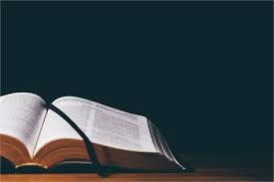

**Sermon: Calvin McCoy**



**SKYVIEW CHURCH OF CHRIST 5972 62ND Avenue N. Pinellas Park, Fl –33782**

